**Task-1(a)**

cd Desktop

cd lab1

cd task1

touch 20301268_1.txt 20301268_2.txt 20301268_3.txt 20301268_4.txt

mkdir odree1 odree2

mv 20301268_1.txt 20301268_2.txt 20301268_3.txt odree1

cd odree1

cp 20301268_1.txt 20301268_2.txt ~/Desktop/lab1/task1/odree2

cd ..

mkdir odree3

cp -r odree1 odree3

cd odree3

ls -l

chmod -R a=rx *

ls -l

cd ..

ls -l

sudo mv odree3 /

rm -r *

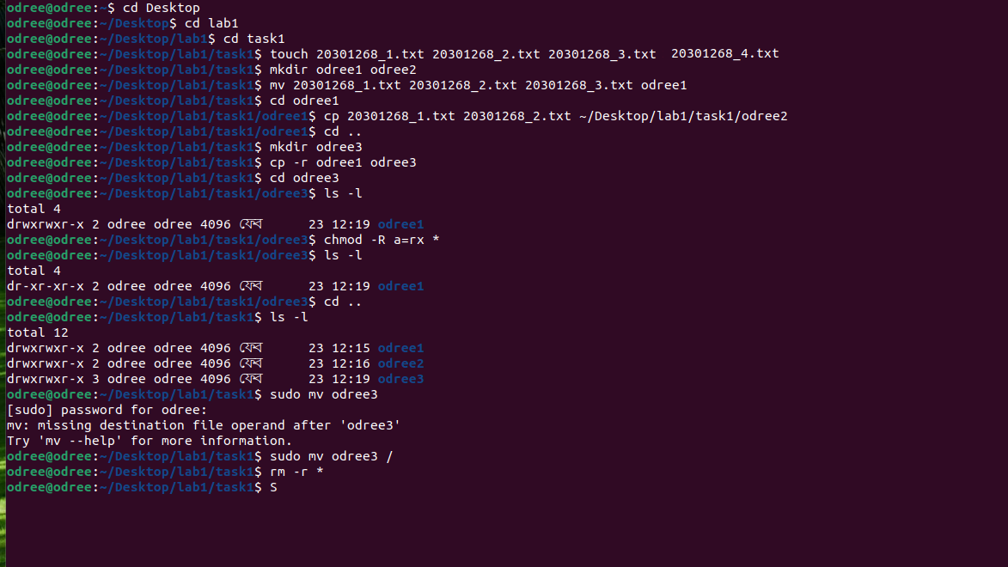

**Task-1(b)**

cat> course.txt

CSE321 sec:08

CSE360 sec:05

PSY101 sec:05

HUM101 sec:02

CTRL+D

grep -c "CSE" course.txt

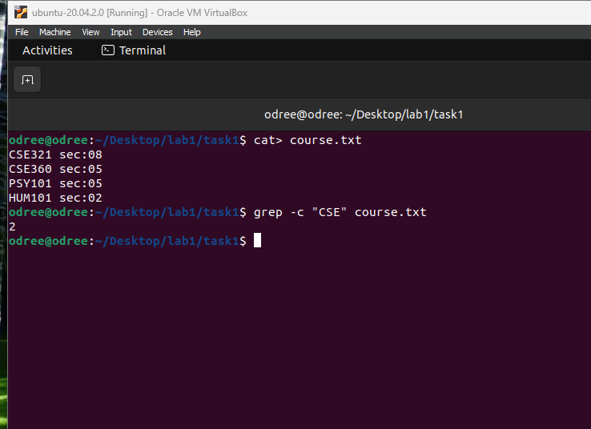

**Task-1(c)**

ls -a /

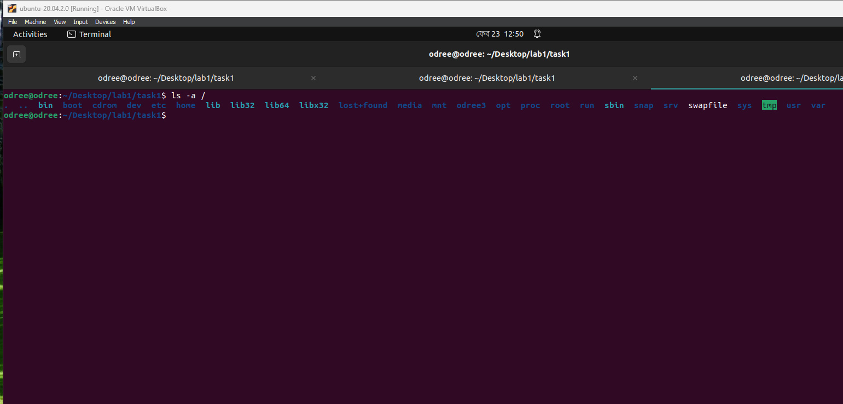

**Task-1(d)**

cat> odree.txt

1

2

3

4

5

6

7

8

9

10

11

12

13

14

15

16

17

18

19

20

21

22

23

24

tail -n +5 odree.txt | head -n 13

